WELCOME to WINTERdon’t you feel a bit warmer just looking at the photo? All you need now is a good book and a block of chocolate, you already have a cup of coffee, but don’t forget to draw straws to see who gets to get up and put another log on the fire and fill the cups.

50TH ANNIVERSARY CELEBRATION AFTERNOON

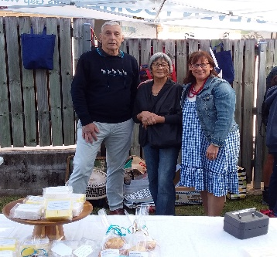

Fifty years ago, a group of people recognised a need, developed a solution and had the drive and foresight to be able to meet that need. Ashgrove Meals on Wheels was the result. Fifty years on we are continuing the work those people started.

The celebration on 21st May recognised the ongoing significant contribution to the community of Ashgrove Meals on Wheels in the fiftieth year of its operation. The celebration demonstrated our appreciation of the hard work and help of the volunteers in all capacities, the staff members, the general community and other volunteer organisations who support Ashgrove Meals on Wheels. It was also a time where we could acknowledge our clients and thank them for their continued support.

It was evident to me that all who attended the celebration event enjoyed the entertainment, the Sausage Sizzle and the stalls offering cakes, plants and face painting. The highlight was the cutting of the special cake by previous Presidents who were in attendance. It was especially lovely to see a variety of age groups who came to spend our special day with us.

Our relationship with our clients and association with other volunteer groups and the Ashgrove community is very special to us, we will continue to provide support by being “more than just a meal”.

Beth Constable,

President Ashgrove Meals on Wheels 





**PHOTOS TAKEN AT THE**

**ASHGROVE MEALS ON WHEELS 50TH ANNIVERSARY CELEBRATION**

**HELD ON SUNDAY 21ST MAY 2023 AT THE PREMISES IN CHIBA STREET, ASHGROVE**

**(The actual day of the 50th Anniversary was the 26th March, 2023. First meal delivered Monday, 26th March, 1973.)**

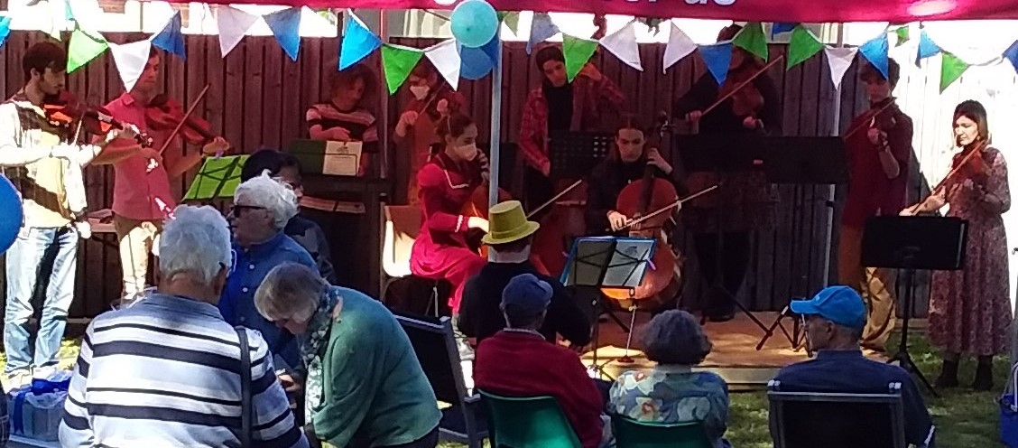

**Music makes the World go around.**

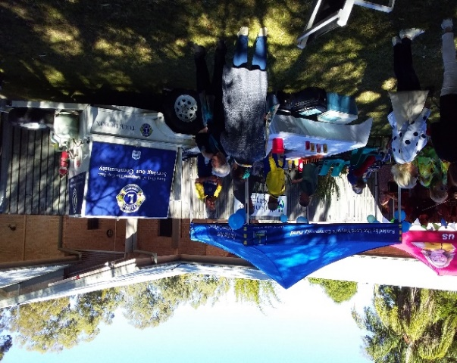 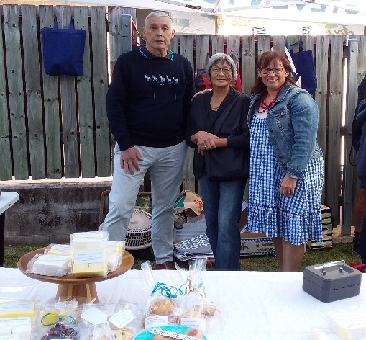****

**Lions Sausage Sizzle/Drink Stall. Cake and Sweet Stall – Lucky man of the day Shai**

**Ron, Fong and Nikki. who won 2nd prize in the**

**Raffle of the day**

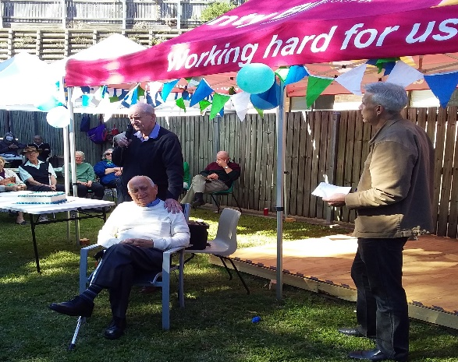 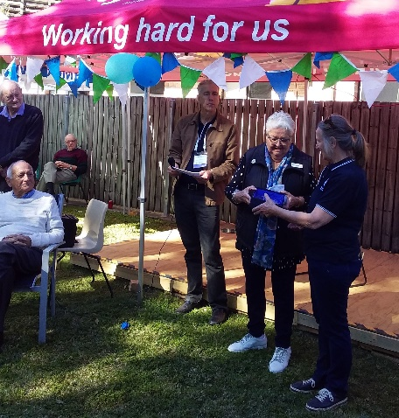

**Matt Webster, Vice President of AMoW Queensland Chairperson, Roslyn Broom,**

**with the two past Presidents of AMoW presenting the 50th Anniversary plaque**

**Frank Long and Brian Crawford, telling how to President of AMoW, Beth Constable.**

**it was in their day at the head of AMoW.**

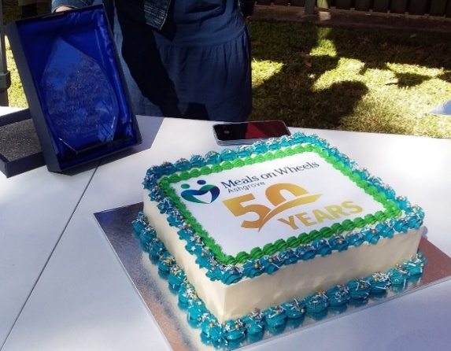

**50th ANNIVERSARY CELEBRATION**

**CAKE and 50th ANNIVERSARY plaque**

**presented to Ashgrove Meals on Wheels.**

THANK YOU EVERYONE …. COMMITTEE, VOLUNTEERS,MP Jonty Bush, LORD MAYOR, Adrian Schrinner, CR. Steve Toomey,

ASHGROVE/THE GAP LIONS CLUB, ROTARY, BUNNINGS, LOCAL STORE KEEPERS, ANYBODY ELSE WHO HAS DONATED THEIR TIME WITH PREPARATIONS OR DONATIONS TO HELP US CELEBRATE ON THE DAY.

**SPECIAL DATES: **

*JUNE SCHOOL HOLIDAYS* – TERM FINISHES FRIDAY, 23RD JUNE 2023 AND

STARTS AGAIN MONDAY 10TH JULY, 2023

*EKKA SHOW DAY* WEDNESDAY, 16TH AUGUST, 2023

*FATHERS’ DAY* SUNDAY, SEPTEMBER 3RD, 2023



Two boys were talking while they were

playing … One said to the other “How long is your Uncle Phil gonna stay with you?”

His friend replied, “I dunno. He’s still looking for a place. I think he must be looking for a farm or somethin’. Dad keeps saying he’ll be at our house “till the cows come home”.

**THANK YOU FROM ASHGROVE MEALS ON WHEELS**

**ACKNOWLEDGEMENT FOR DONATIONS FROM 28 FEBRUARY TO 31 MAY 2023**

24.03.2023 Jonty Bush MP COOPER $326.00 Donation

06.04.2023 Client $100.00 Donation

21.04.2023 Client $100.00 Donation

02.05.2023 Jonty Bush MP COOPER Gift basket for raffle prize for 50th Celebration

12.05.2023 Client $30.00 Donation

15.05.2023 Alex Rutherford Property Gift basket for 50th Celebration

20.05.2023 Woolies Ashgrove Ice for 50th Celebration

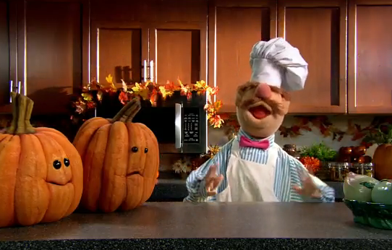**FROM THE KITCHEN:**

**BREAKFAST –** Do you know the old saying “Breakfast – eat like a King”,“Lunch – eat like a Prince”, and “Dinner – eat like a Pauper”? Well, we don’t have to eat like the above, but we should eat something nutritious for breakfast, that is why we at AMoW have the solution for you. We have a ‘breakfast bundle’ already packed and ready to be delivered with your meal on your delivery day. In your Breakfast Bundle, you will receive --½ loaf of bread, 1 ltr of milk, 1 ltr of juice, 3 containers of a variety of tinned fruit and 7 packets of various types of cereal.

**PLEASE CALL THE OFFICE ON 33664299** if you would like to start receiving the Breakfast Pack with your next meal delivery.



****HEATERS and CANDLES –The Fire Department has asked us all to please take care when turning on your heater so that you don’t let any blankets, clothes,children, paper etc get too close or touch the appliance in case it starts fire. Candles are very pretty and smell lovely but they are too dangerous around materials, children, animals. Also make sure you have FIRE ALARMS installed in your home. These alarms should be checked yearly to make sure they are working correctly in an emergency situation – it could mean a matter of life and/or the loss of your home and contents. ALWAYS HAVE EMERGENCY TELEPHONE NUMBERS CLOSE TO YOUR PHONE FOR EASY ACCESS IF NEEDED.**

**CAN YOU NAME THE PERSON WHO INVENTED EACH OF THE FOLLOWING ITEMS OR IDEAS?**

1. **He developed the first telephone**
2. **He invented the safety razor**
3. **He developed the phonograph**
4. **He started the assembly line technique for cars**
5. **5. He invented a code of dots and dashes**
6. **He conceived the theory of universal gravitation**
7. **He discovered the laws of heredity**
8. **He is the father of medicine**
9. **He is credited with the invention of movable printing**

**10.He invented the hand held camera**

***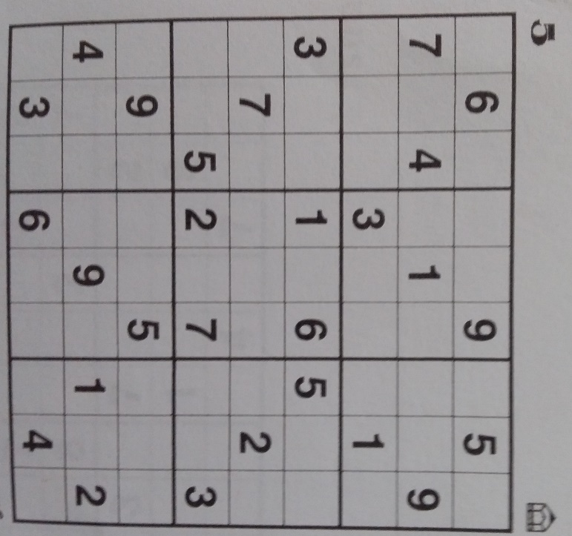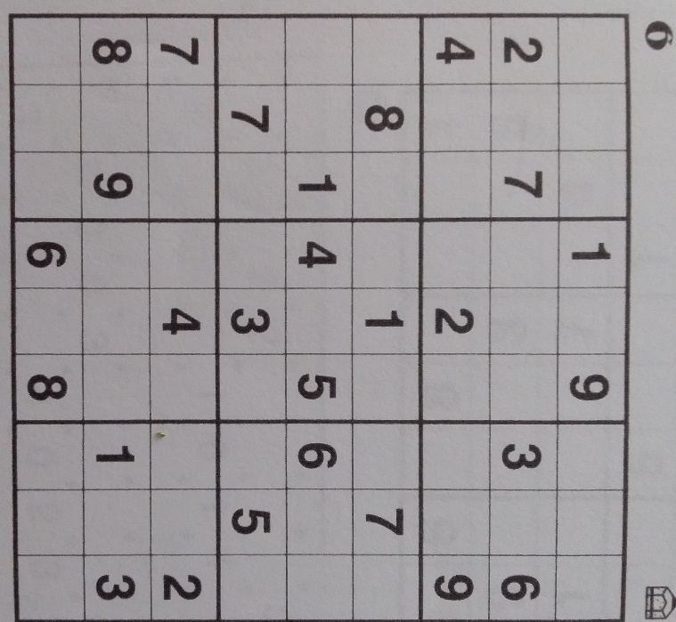******SUDUKO - answers at the back***

***SPECIAL VISITORS***

***On Tuesday 9th May, some of our clients were visited by a number of Broncos players who delivered their meals and a small gift to them.***

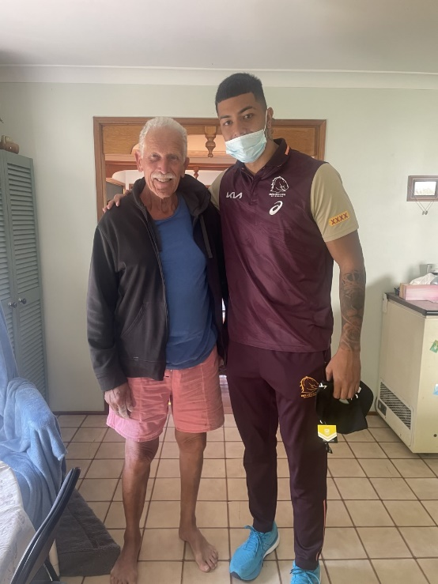 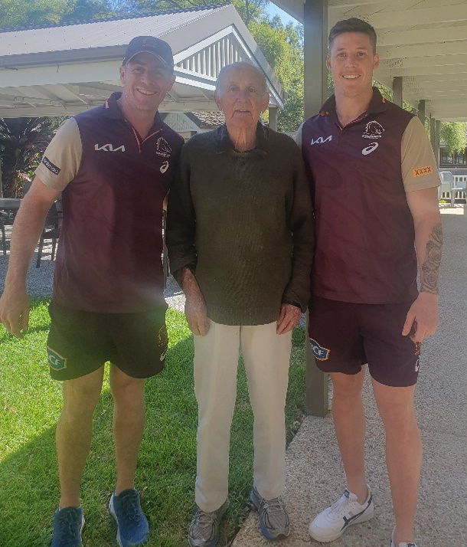

1. ***Eddie Vincenzie 2. Percy Fleming***

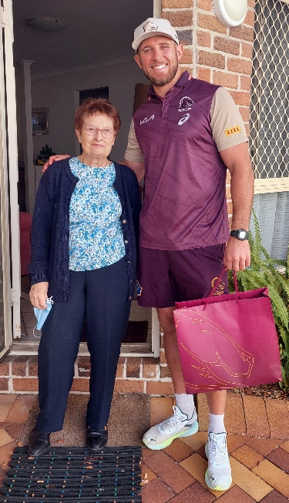 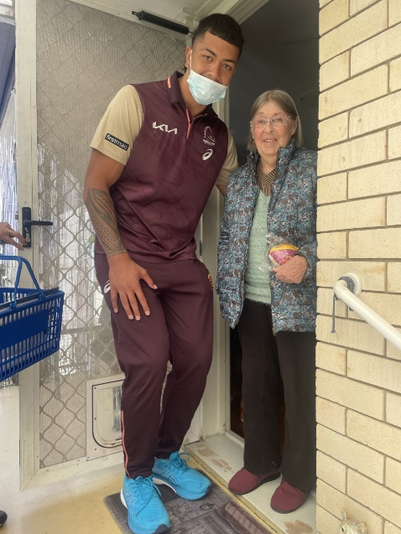

***3. Margaret H.C. 4. Margaret Burgess***

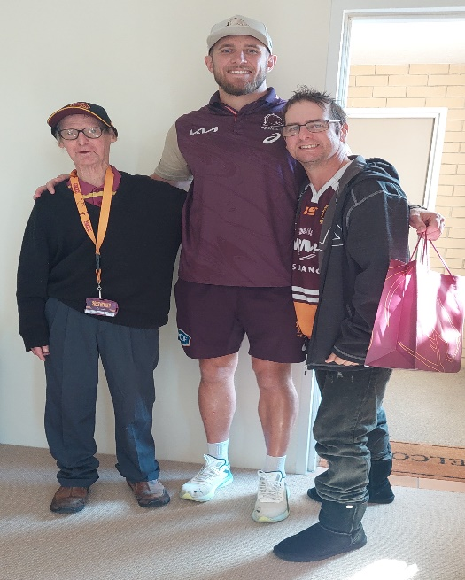 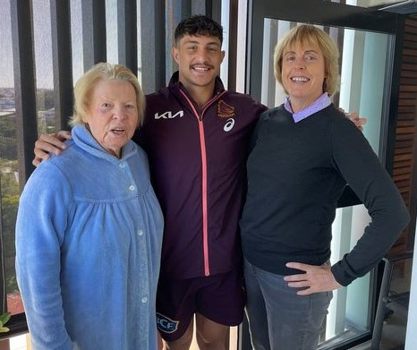

***5. Greg 6. Eileen, Kotani Staggs and Helen Baker***

***SUDUKO answers***

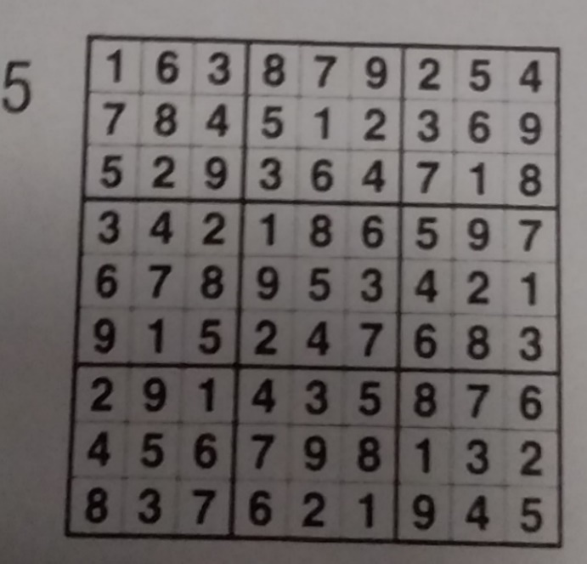 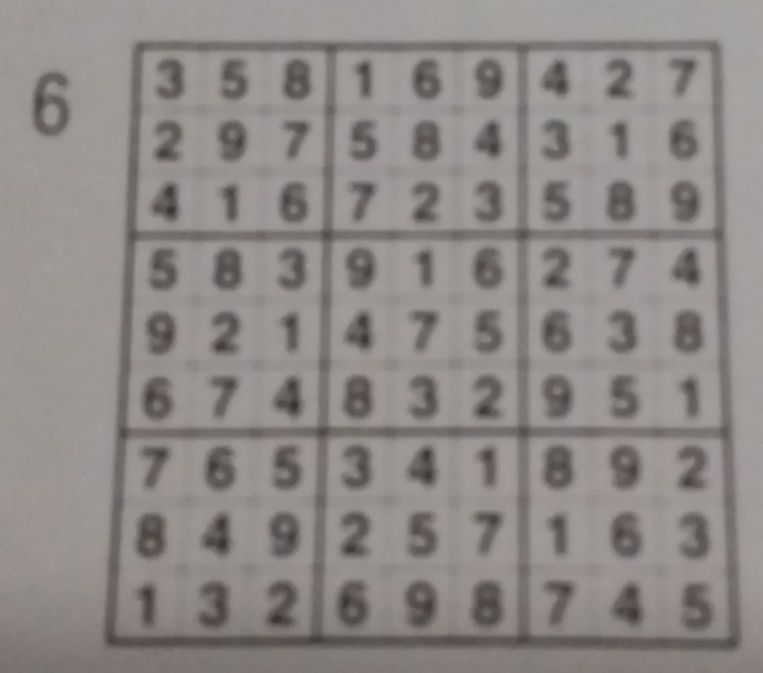

***ANSWERS TO INVENTIONS QUESTIONS***

**1.Alexander Graham BELL 6. Isaac NEWTON**

**2. King GILLETTE 7. Gregor MINDEL**

**3. Thomas EDISON 8. HIPOCRATES**

**4. Henry FORD 9.Johann GUTENBURG**

**5. Samuel MORSE 10. George EASTMAN**

***SENIOR EXERCISES ..***

***(NOTE – PLEASE HAVE YOUR PARENTS TRY THESE FIRST REMEMBER THEY ARE YOUR SENIORS)***

***The Doctor told me to start an exercise program. Not wanting to harm this old body, I’ve devised the following:***

**MONDAY** Beat around the bush

Jump to conclusions

Climb walls

Wade through the the morning paper

**TUESDAY**  Drag my heels

Push my Luck

Make mountains out of mole hills

Hit the nail on the head

**WEDNESDAY** Bend over backwards

Jump on the Band Wagon

Run around in circles

**THURSDAY** Advise the Prime Minister how to run the country..

Toot my own horn

Pull out all of the stops

Add fuel to the fire

**FRIDAY** Open a can of worms

Put my foot in my mouth

Start the ball rolling

Go over the edge

**SATURDAY** Pick up the pieces

**SUNDAY** Kneel in prayer

Bow my head in thanksgiving

Uplift my hands in praise

Hug someone and encourage them…



**WHAT A WORKOUT!**

**NEW TITLES FOR OLD SONGS**

**Herman’s Hermits – *Mrs Brown, You’ve got a lovely walker*.**

**Tony Orlando – *Knock 3 times on the ceiling if you hear me fall*.**

**Helen Reddy – *I am woman, hear me snore.***

**Leslie Gore – *It’s my procedure, and I’ll cry if I want too.***

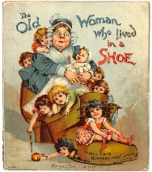

**LAST WORDS**

Imagination is stronger than knowledge….dreams are more powerful than facts, and hope can triumph over experience.

Whatever setbacks you encounter, don’t give up on your

hopes and dreams.



**Val 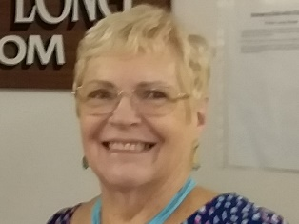 Editor**

**50 years old ASHGROVE MEALS ON WHEELS 50 years old**

**MORE THAN JUST A MEAL**

**DELIVERING TO ASHGROVE AND ADJACENT AREAS**

**As our part of community caring we aim: To provide a wholesome and appealing meal,**

**To be delivered in a friendly, understanding way.**

**Ashgrove Meals on Wheels, 524 Waterworks Road, Ashgrove.**

**All enquiries Please telephone 3366 4299**

**Email – admin@ashgrovemealsonwheels.org.au**

***This newsletter has been printed with courtesy of Jonty Bush MP, Cooper Electoral Office, Ashgrove.***

***DISCLAIMER – Reasonable efforts have been made to ensure the accuracy of the content of this newsletter at the time of preparation.***

***Opinions expressed in this Newsletter are those of the Editor and not necessarily those of the AMOW team.***