Can you believe another year has flown by so fast.

To all of our wonderful volunteers, clients and staff at Meals on Wheels Ashgrove, I hope this finds you in good health. I hope is that you are all able to spend time with family this
Christmas, or if you are unable to do so, that you can spend some of that time with friends. For those of us who are able to spend time with the ones we love and care for, if we could spend a moment to think of those of us less fortunate than ourselves this Christmas.

A strong community spirit is at the core of everything we do at Meals on Wheels. I have always been impressed with the incredible way in which the community comes together with so many people reaching out to give their time, and their energy to volunteer on a regular basis, and also to care for each other and to provide and deliver nutritious meals to our clients. We are grateful to be in a position to assist people in our area and personally I am extremely proud of how all our volunteers and staff have worked together for a common goal this year as we have past 50 years, yes … this year is our 50th Christmas providing nutritious and delicious meals to our clients.

May your Christmas sparkle with moments of love, laughter and goodwill. I’d also like to wish you a New Year full of joy and prosperity. Have a Merry Christmas.
Jason,
President Ashgrove Meals on Wheels

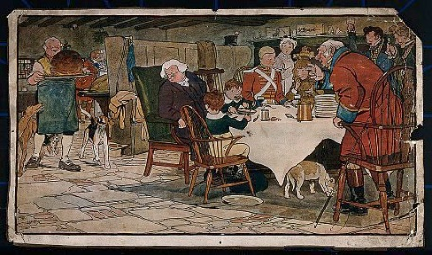
In the Christmas Newsletter for December 2019, we started on a journey to find out when it was the ‘thing’ to place ‘coins or tokens’ in the Christmas pudding, so for those of you who did not receive a copy, here is the next installment on this journey.
Finding a Christmas coin in your slice of pudding is believed to bring ‘Good Luck’ and Wealth in the coming year for you. This tradition may date back as early as the 1300’s when a dried pea or sometimes a silver or crown coin was baked into a 12th Night Cake. A silver sixpence was placed in the pudding mix by each member of the household who gave the mix a stir. Whoever found the coin in their own slice of pudding on Christmas Day would see it as a sign that they would have good luck/and or wealth for the year to come. Traditionally in England, small silver charms were baked in the Christmas pudding, a silver coin was a sign of wealth in the coming year -in some cases it meant that you would be crowned ‘King’ or ‘Queen’ for the night; a tiny wishbone, good luck; a silver thimble, thrift; or spinsterdom; an anchor, a safe harbour; for a single man; a single button meant that he would be single for the year. If you are old enough to remember the ‘ring’, this meant marriage. I can remember as a child that were absolutely thrilled if we found threepences in the Christmas pudding tried to find more if any of the pudding was left. I still have some threepences, do you? The pudding was a great part of Christmas!

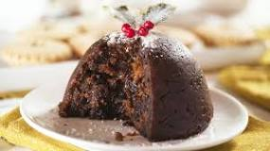
A Christmas Pudding should have thirteen ingredients that represent Jesus and the 12 disciples. Traditionally these 13 ingredients are:- raisins, currants, suet, brown sugar, breadcrumbs, citron, lemon peel, orange peel, flour, mixed spices, eggs, milk and brandy. Stirring the pudding should be from East to West in honour of the Magi (Wise Men) who came from the east to visit the baby Jesus. It’s also a good excuse to enjoy a wee dram or a cup of festive mulled wine.

In the 1600’s it was customary for the Lord of the Manor to give his bride a piece of silver as a wedding gift. This was symbolically represented by a sixpenny coin. It was later to become a tradition to include a sixpence in her dowry that was given by the bride’s father to the groom.

Nicknames were given to ‘sixpences’ (or nowadays we call them ‘five cent pieces the equivalent of the sixpence) and one name was the “bender” because due to its silver content it could be bent in the hands. This was commonly done to create “love tokens”, many of which survive in collections to this day. The “Tanner” was another nickname given to the ‘sixpence’ although how this came about is something of a mystery. Some attribute the name to John Sigismund TANNER (1705-1775) who was a former Chief Engineer of the Royal Mint and who designed a sixpence during the reign of King George II. The Rare Sixpence of 1952. These scarce silver sixpence coins are prized collector items. When King George VI, who died in February, 1952, Elizabeth, his eldest daughter became Queen Elizabeth II later that same year. Coin collectors began to collect this rare coin and so today if you find any sixpences what that date stamped on it, you have a very rare coin indeed.

England banned Christmas and saw it as a wasteful festival that threatened Christian beliefs and encouraged immoral activities, “to the great dishonor of God”. This discontent within the Puritan community towards festivals led to the enactment of forceful legislation even before Cromwell’s protectorate.

Scotland bans Christmas. Before the Reformation in 1560, Christmas had been a religious feasting day. Then, with a powerful Kirk frowning upon anything related to Roman Catholics, the Scottish Parliament passed a law in 1640 that made celebrating ‘Yule vacations’ illegal. This law went on for 400 years. While parts of each act was repealed in 1686 to 1712 respectfully, the Church of Scotland continued to discontinue ‘Yule’ celebrations. Christmas was only recognized as a public holiday in Scotland in 1971. Hogmanay remained the focus of Scottish celebrations for centuries, and was recognized as a public holiday before other parts of Britain.

Norwegians take superstitions to a new level, as on Christmas Eve, so the story goes, people across the country hide their brooms, as evil spirits and witches awake on this night will take them to ride across the country if they are not hidden in the closet. SO HIDE YOUR BROOMS AND MOPS!

So hide your brooms and mops away (then forget where you hid them and relax after Christmas and leave the housework alone for another day). Just another thought to brighten up your Christmas, if you have spider’s webs hanging around, throw some tinsel on them to brighten up the area where you found them. You will be amazed how pretty they look and the spiders will thank you for making their webs look good for the season.

Warmest wishes for a wonderful Christmas and a happy and healthy 2024
from the Committee, Staff and Volunteers at Ashgrove Meals on Wheels.

This year, we are again delivering to each client a Christmas bag.
Each Christmas gift bag contains contributions kindly donated by:

Ashgrove Meals on Wheels
Councillor Steve Toomey, The Gap Ward Office
Elizabeth Watson-Brown MP for Ryan
Jonty Just MP Member for Cooper
Officeworks Windsor
St John’s Wood Scouts
The Gap C&K Community Kindy
----------------------------------------------------------------------------------------------------------------------------------------

ASHGROVE MEALS ON WHEELS RETAINING WALL
GOOD NEWS ---For those of you who attended our 50th ANNIVERSARY CELEBRATIONS IN MAY THIS YEAR, you will be pleased to see that the retaining wall at the entrance to our front area has been finished and looks wonderful!
Other renovations, including the stairs beside the building leading downstairs to the grassed area and vegetable garden have also been updated. Here is a before and after of the retaining wall and Office area for you to see how good it looks.

Before June 2017 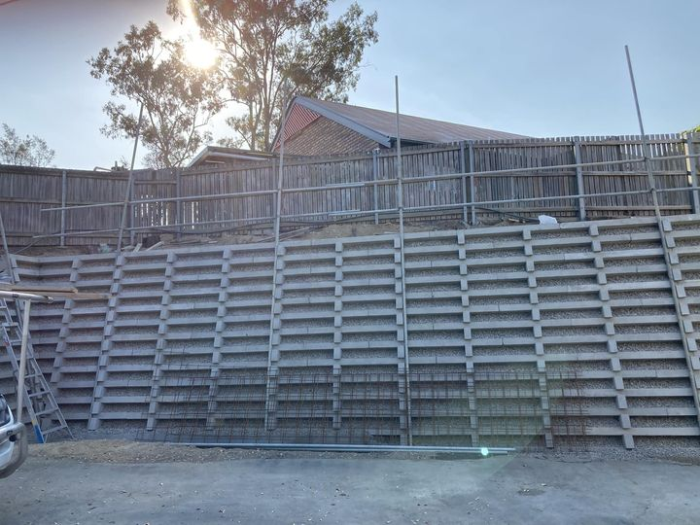After October 2023

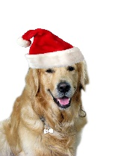
THANK YOU FROM ASHGROVE MEALS ON WHEELS
ACKNOWLEDGEMENT FOR DONATIONS FROM 1ST AUGUST TO 11th DECEMBER 2023

18.10.2023 Ashgrove/Bardon RSL $1,000 donation
25.10.2023 Volunteer $40.00 donation
25.10.2023 Client $100.00 donation
04.11.2023 Volunteer’s wife $50.00 donation
13.11.2023 Client $50.00
24.11.2023 Woolworths Paddington $50.00 gift card for Bunnings BBQ
30.11.2023 Woolworths Ashgrove $50.00 gift card for Bunnings BBQ
01.12.2023 Steve Toomey, The Gap Ward Office Christmas cookies for clients Xmas gift bags
04.12.2023 Coles Ashgrove $50.00 gift card for Bunnings BBQ
04.12.2023 Officeworks Windsor Gift bags for clients Christmas gifts
04.12.2023 Jonty Bush MP Member for Cooper Panettone Xmas gifts for clients
11.12.2023 Client $20.00 donation

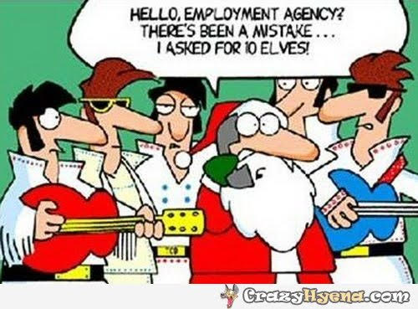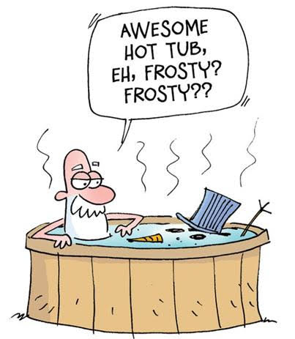

Messages from the Office regarding meals deliveries

Number 1

ASHGROVE MEALS ON WHEELS CHRISTMAS/NEW YEAR HOLIDAY MEAL SCHEDULE 2023/2024

Dear Client,

Ashgrove Meals on Wheels will be closed for the Christmas Public Holidays on Monday 25/12/23 and Tuesday 26/12/23 and for New Year's Public Holiday on Monday 1/01/24.

Meals for Monday 25/12/23 and Tuesday 26/12/23 will be delivered on Thursday 21/12/23.

Please note that whilst we do not normally deliver on Thursdays, we are doing so on this date due to the large volume of meals being delivered.

Meals for New Year’s Day Public Holiday Monday 1/01/24 will be delivered with the Friday delivery on 29/12/23.

MERRY CHRISTMAS AND A HAPPY NEW YEAR!

PLEASE RETURN THE SLIP BELOW BY
MONDAY 18TH DECEMBER 2023 OR CALL THE OFFICE ON 3366 4299

- - - - - - - - - - - - - - - - - - - - - - - - - - - - - CUT HERE - - - - - - - - - - - - - -- - - - - - - - -

Name: ………………………………………………Route:………..........….

Please circle Yes or No below if you require meals for following:

MEAL FOR MONDAY 25 DEC 2023 YES NO

MEAL FOR TUESDAY 26 DEC 2023 YES NO

MEAL FOR MONDAY 1 JAN 2024 YES NO

Number 2
ASHGROVE MEALS ON WHEELS SALAD OPTION

Dear Client,

We will be offering an optional salad for the summer months on a Friday commencing from Friday 1st December 2023 until Friday 1st March 2024.

The salad can either replace your main meal or can be an additional meal.
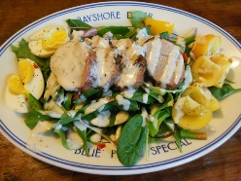
If you do not return this note, then we will assume that you are hapy to continue as per your normal meal schedule.

The salad will be the Chef’s choice of the day, and examples of the type of salads
include but are not limited to:

Chicken Caesar Salad Greek Salad
Egg & Cheese Salad Ham & Relish Salad
Silverside & Pickle Salad Roast Beef Salad

Please return the below slip to your delivery volunteer and please advise us of any dietary requirements in relation to the salads.

Cut here and return to the delivery volunteer

Name:______________________________Route:________________________

YES - I would like to receive a salad meal to replace my main meal

YES – I would like to receive a salad meal as an additional meal

If you have any dietary requirements in relation to the salads, then please list them below:

______________________________________________________________________________________
Just for Christmas and for people who like to eat out, go to the gym, go on cruises, like ducks and are hopeful of getting through life with a cat!
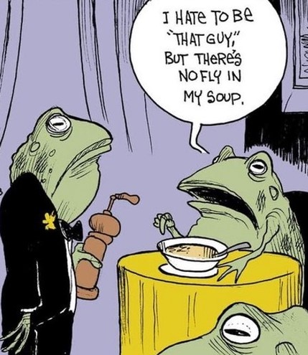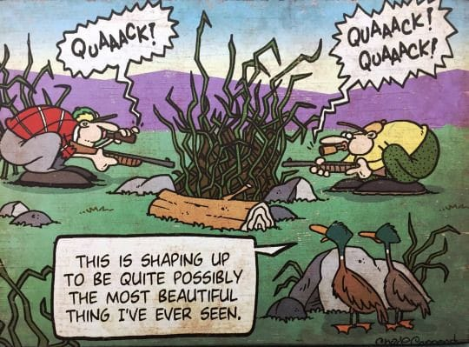
KIDS -DON’T YOU JUST LOVE THEM – ESPECIALLY IF YOU ARE A TEACHER?

TEACHER: Harold, What do you call a person who keeps on talking when people are no longer interested?
HAROLD: A Teacher.
TEACHER: Clyde, your composition on ‘My Dog’ is exactly the same as your brother’s. Did you copy his?
CLYDE: No Sir; it’s the same dog.
---------------------------------------------------------------------------------------------------------------------------------------------------------------
TEACHER: Donald, what is the chemical formula for water?
DONALD: H I J K L M N O
TEACHER: What are you talking about?
DONALD: Yesterday you said it’s H to O.
TEACHER: Glenn, how do you spell ‘crocodile?’
GLENN: K-R-O-K-O-D-I-L-E
TEACHER: No, that’s wrong.
GLENN: Maybe it is wrong, but you asked me how I spell it
--------------------------------------------------------------------------------------------------------------------------------------------------------------.
TEACHER: How old is your father?
KID: He is 6 years old.
TEACHER: What? How is this possible?
KID: He became a father when I was born.
--------------------------------------------------------------------------------------------------------------------------------------------------------------
TEACHER: Maria, go to the map and find North America.
MARIA: Here it is.
TEACHER: Correct. Now, Class, who discovered America?
CLASS: Maria.
SUDOKO
NO. 53 NO.55
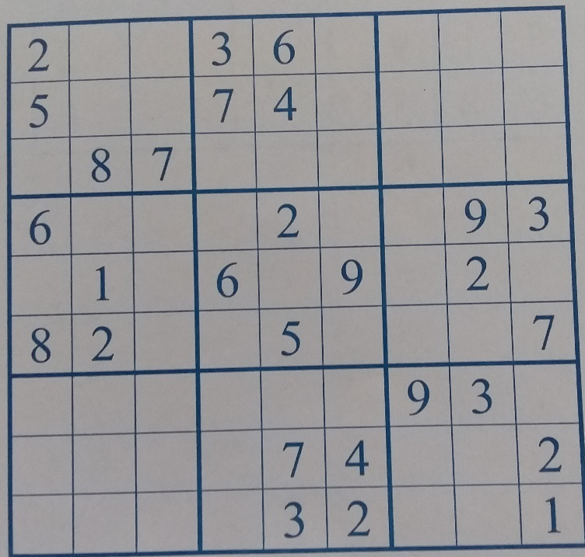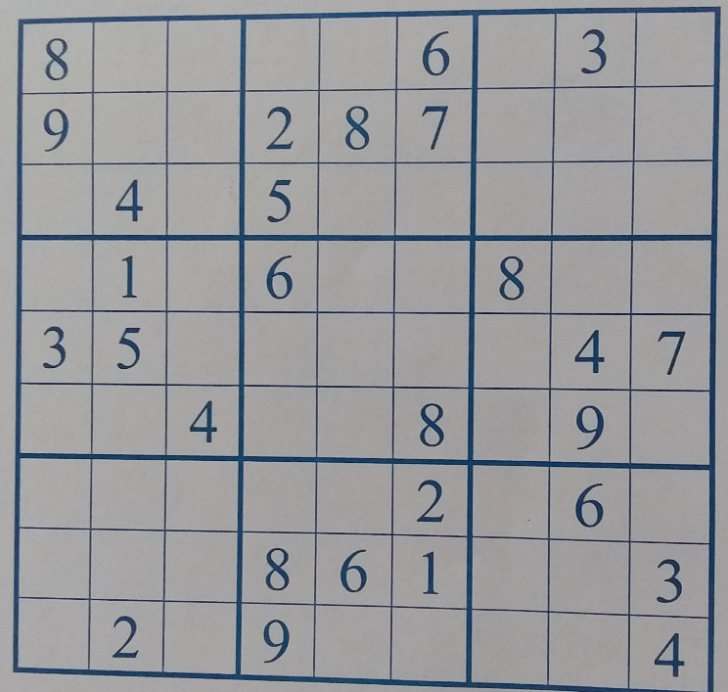

CAN YOU NAME THE FAMOUS PEOPLE WHO IDENTIFY WITH THESE PHRASES?
- “I want to be alone”..
- “The only thing we have to fear is fear itself”
- “I shall return”
- “I have nothing to offer but blood, tears and sweat”
- “How to win friends and influence people”
- “Come up and see me sometime”
- “You ain’t heard nothin’ yet, folks”
- “I think that I shall never see a poem as lovely as a tree”
- “But I have promises to keep, and miles to go before I sleep”
- “The Sudetenland is the last territorial claim I have in Europe”
- “It ain’t a fit night out for man or beast”
- “Mr. Watson, come here, I want you”
- “From each according to his abilities, to each according to his needs”
- “How do I love you, let me count the ways”
- “I believe it is peace for our time”
- “Speak softly, and carry a big stick”
- “I have been to the mountain”
- “England expects every man will do his duty”
- “He who can, does, he who cannot, teaches”
- “Mad dogs and Englishmen go out in the midday sun”

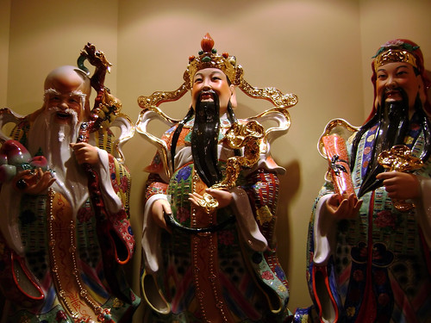
wISE WORDS

One who asks a question is a fool for five minutes;
One who does not ask a question remains a fool forever.

Chinese proverb.

Val 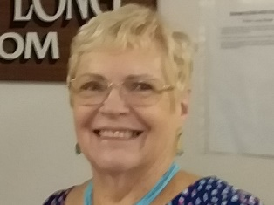 Editor
ASHGROVE MEALS ON WHEELS
MORE THAN JUST A MEAL
DELIVERING TO ASHGROVE AND ADJACENT AREAS
As our part of community caring we aim: To provide a wholesome and appealing meal,
To be delivered in a friendly, understanding way.
Ashgrove Meals on Wheels, 524 Waterworks Road, Ashgrove.
All enquiries - Please telephone 3366 4299
Email – admin@ashgrovemealsonwheels.org.au

This newsletter has been printed with courtesy of Jonty Bush MP, Cooper Electoral Office, Ashgrove.
DISCLAIMER – Reasonable efforts have been made to ensure the accuracy of the content of this newsletter at the time of preparation.
Opinions expressed in this Newsletter are those of the Editor and not necessarily those of the AMOW team.

GOODBYE UNTIL NEXT YEAR SANTA and his REINDEER

ANSWERS TO PUZZLES

SUDOKO NO. 53 NO. 55
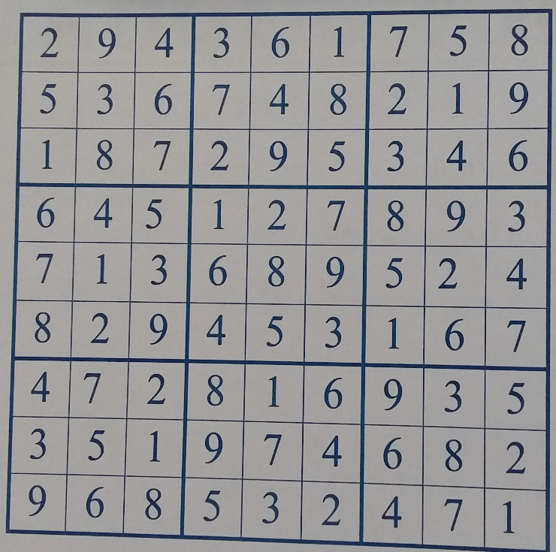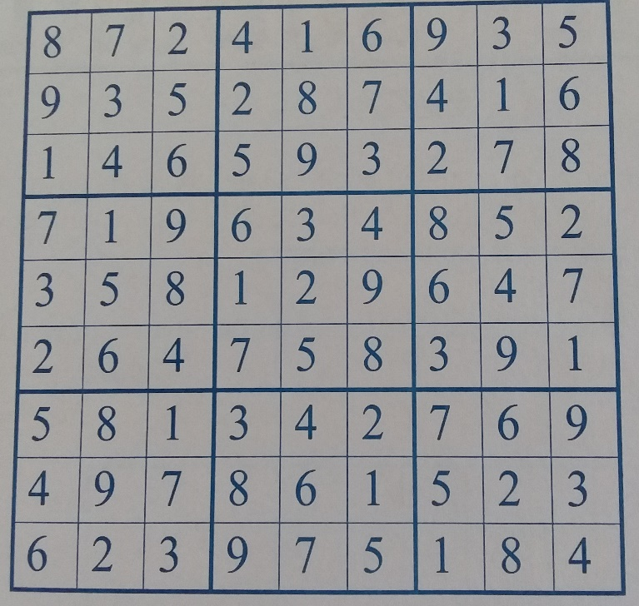

ANSWERS TO FAMOUS SAYINGS
- Greta Garbo
- Franklin D. Roosevelt
- DouglasMacArthur
- Winston Churchill
- Dale Carnegie
- Mae West
- Al Jolson
- Joyce Kilmer
- Robert Frost
10.Adolf Hitler
11.W.C. Fields
12. Alexander Graham Bell
13. Karl Marx
14. Elizabeth Barrett Browning
15. Neville Chamberlain
16. Theodore Roosevelt
17. Martin Luther King, JR.
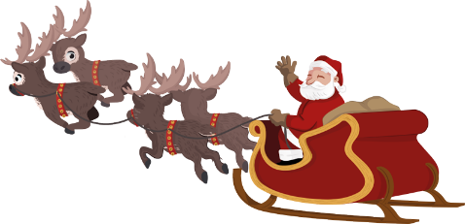
18. Horatio Nelson
19. George Bernard Shaw
20. Noel Coward

